

EBAY CONTROLLER TEST DATA SHEET

P/N: EBAY 414-8005 Date: 27/03/2018 Time: 14:21

S/N: 281 Tested by: admin

Hardware Rev: BLDC_60A_V6 Approved by: admin

Software Rev: 5.3.9

Tester Software Version: 1.2g

Equipments Used

Equipments Model No Serial No

Power Supply

Digital Multimeter

CAN Interface

Resistance Decade Box

PC

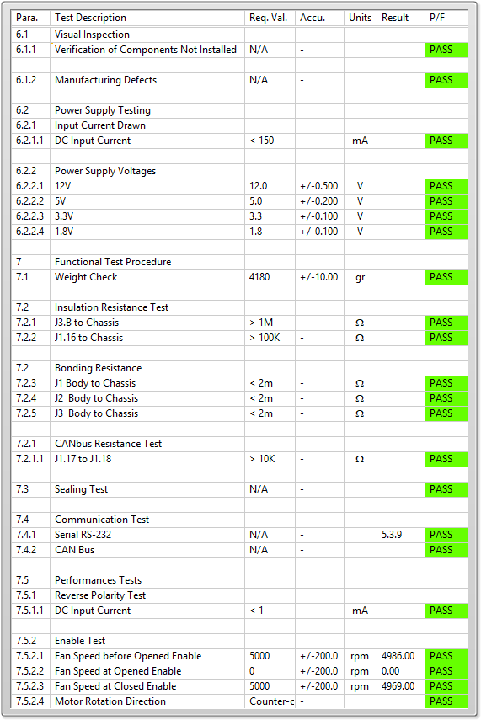

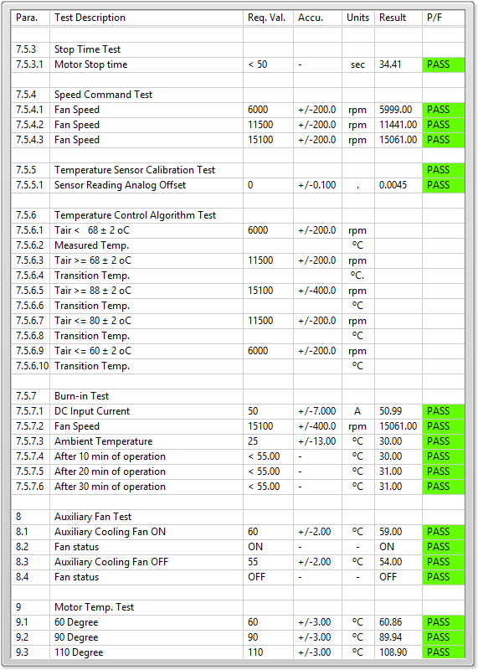

General result:

Test-Operator:____ admin_________ Q.A.:__________________________